**Key Findings From Report**

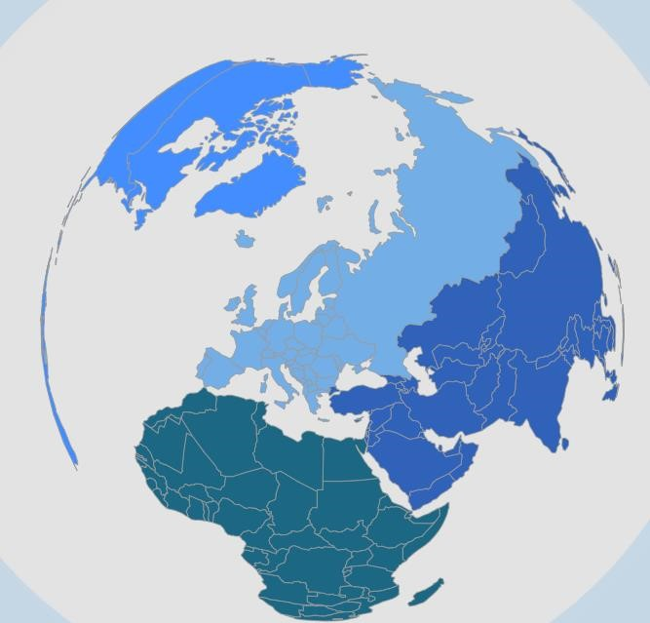

**WORLD**

**LAYOFFS**

**(2020**

**–**

**2023)**

Created by: Daniel

Olaniyi

T

